

**Pokhara University**

**SCHOOL OF ENGINEERING**

**Bijaypur, Pokhara-26**

**A**

**Project Report on**

**“Online Home Rental System”**

for the partial fulfillment of requirements for the degree of Bachelor of Engineering in Computer Engineering

**Submitted by :**

Anil Kumar Tiwari (19070091)

Bidhata Pandey (19070099)

Prasiddhi Adhikari (19070116)

Lokesh Subedi (19070025)

**Submitted to :**

Department of Computer Engineering

School of Engineering

2022

# TitlePage

**A**

**Project Report on**

“**Online Home Rental System**”

for the partial fulfillment of requirements for the degree of Bachelor of Engineering in Computer Engineering

**Submitted by :**

Anil Kumar Tiwari (19070091)

Bidhata Pandey (19070099)

Prasiddhi Adhikari(19070116)

Lokesh Subedi (19070025)

# **CERTIFICATE OF ACCEPTANCE**

This project proposal entitled "**Online Home Rental System**" submitted by Mr. Anil Kumar Tiwari ,Ms. Prasiddhi Adhikari ,Ms. Bidhata Pandey & Mr. Lokesh Subedi as a partial fulfillment for the requirement of Bachelor of Computer Engineering has been examined by us and is accepted.

**Panel of Examiners:**

| **Name** | **Signature** | **Date** |
| --- | --- | --- |
|  |  |  |
|  |  |  |
|  |  |  |
|  |  |  |
|  |  |  |
|  |  |  |
|  |  |  |
|  |  |  |
| **Project Supervisor:** |  |  |
|  |  |  |
| Er. Rajesh Kunwar | ………………… | …………………….. |
| **Program Coordinator:** |  |  |
|  |  |  |
| Dr. Uday Raj Dhugana | ………………… | …………………….. |

# ACKNOWLEDGEMENT

This project was done as per the requirement of the 6th semester minor project in Bachelor of Computer Engineering, Pokhara University, Nepal. We would like to express our deepest gratitude to **Er. Uday Raj Dhungana** and **Er. Rajesh Kunwar** for supervising this project with full dedication, support and guidance. Without them, this project would have taken twice as long to complete.

We would like to acknowledge all the authors of the research papers that helped us understand the required concepts as well as algorithms better, and that we utilized to prepare this report. Every attempt has been made to include each and every aspect of the project in this report so that the reader can clearly understand our project. We would be pleased to get feedback.

Sincerely,

Anil Kumar Tiwari

Bidhata Pandey

Prasiddhi Adhikari

Lokesh Subedi

# ABSTRACT

Science and Technology has changed this world into a small, secure, and easy-to-manage activity for individuals and organizations. The Internet is a great attraction for users’ attention as well as a great interaction channel for connection renters and landlords. Thus, the use of the “Online Home Rental System” is a web-based platform needed to manage, search and book the housing system easily. In order to give easy access to find the rooms/flats and select no. of rooms as per the renter's need and to upload the location, contact No., expected rent, No. of Rooms, Facilities, and other information by the tenant, the web application has been developed in this documentation. It will take so much time for people to find their rentals. To solve this problem, we need a platform to help people find a house. The owner can also promote their house on the platform to attract the people. The system will find the nearby house rental that is available and it will make comparisons with other houses for the student to make their choice according to the features requirement.

Keywords:

Online Home Rental System, Web-based Room Rental System,

# LIST OF FIGURES

| **S. No.** | **Figure No.** | **Figure Title** | **Page No.** |
| --- | --- | --- | --- |
| 1. | Fig 1. | SDLC phases | 8 |
| 2.  3.  4.  5. | Fig 2.  Fig 3.  Fig 4.  Fig 5. | Gantt Chart  ER Diagram  UseCase Diagram  Context Diagram | 10  11  12  13 |
|  |  |  |  |

# LIST OF TABLES

| **S. No.** | **Table No.** | **Table Title** | **Page No.** |
| --- | --- | --- | --- |
| 1. | Table 3.1 | Software Requirement Specification | 10 |
|  |  |  |  |
|  |  |  |  |

# LIST OF ABBREVIATION

| ERD | : | Entity Relation Diagram |
| --- | --- | --- |
| SDLC | : | Software Development Life Cycle |
|  |  |  |
|  |  |  |

# LIST OF SYMBOLS

| α | : | Alpha |
| --- | --- | --- |
|  |  |  |
|  |  |  |
|  |  |  |

# Table of Contents

# 

**TitlePage** **1**

**CERTIFICATE OF ACCEPTANCE** **1**

**ACKNOWLEDGEMENT** **3**

**ABSTRACT** **4**

**LIST OF FIGURES** **5**

**LIST OF TABLES** **5**

**LIST OF ABBREVIATION** **6**

**LIST OF SYMBOLS** **7**

**Table of Contents** **8**

CHAPTER 1 1

INTRODUCTION 1

1.1 Background 1

1.2 Motivation 1

1.3 Statement of Problems 2

1.4 Objectives 2

1.5 Application 2

1.6 Scope & Limitation 3

1.6.1. Admin 3

1.6.2. Owner 3

1.6.3. Users 3

1.7 Organization of Report 4

**CHAPTER 2** **4**

**LITERATURE REVIEW** **5**

Traditional system 5

Our System 5

Related Task 5

**CHAPTER 3** **6**

**METHODOLOGY** **7**

3.1 Iterative And Incremental Model 7

3.1.1 Initial Planning Phase 8

3.1.2 Planning Phase 8

3.1.3 Requirements Phase 8

3.1.4 Analysis and Design Phase 8

3.1.5 Implementation Phase 8

3.2 Generic Model 9

3.3 Project Management 9

3.3.1 Team Member: 9

3.3.2 Feasibility Analysis 9

3.3.3 Work Schedule 10

3.4 Requirement Elicitation 10

3.5 System Design and Modeling 11

3.5.1 ER Diagram 11

3.5.2 Use Case Diagram 12

Fig: Context Diagram 13

3.6 Coding tools and platform 13

3.7 Testing 14

Testing Phase 14

The evaluation Phase 14

Deployment Phase 14

**CHAPTER 4** **15**

**LIMITATION AND FUTURE WORKS** **16**

**CHAPTER 5** **16**

**CONCLUSION** **17**

**REFERENCES** **18**

# 

## CHAPTER 1

## INTRODUCTION

## 1.1 Background

We must look for a nearby house to rent as a student/user who studies distant from home and doesn't get a hostel. Students typically prefer to rent homes that are close to their university. It will be difficult for a student looking to rent a home to find one with them. In most cases, the owner does not market their home; instead, word of mouth among the neighbors serves as advertising. To find a rental home, the student must consult the locals, which will take a lot of time. This system's goal is to assist the student in locating.

## 1.2 Motivation

As a student that studies far away from home and doesn't get a hostel, we have to find a nearby house to rent. House rentals that are nearby to the University are usually a student's choice. The student that wants to rent a house will hardly find a suitable one with them. Not all house rentals on the website are available and some of them are located very far from the University. The owner usually does not advertise their house as they just spread the house to the resident's mouth to mouth. The student has to ask the resident around to find the available rent house and it will take so much time. The purpose of this system is to help the student to find a rented house easily. This system will show the available house to rent and make comparisons to help the student in making their choice.

## 1.3 Statement of Problems

Users/We (students at Pokhara University) will have a tough time locating a rental home because they are unaware of the closest houses that are accessible in Pokhara. When some of them conduct searches on specific websites, they frequently discover a rental home that is far from the institution. There are several housing rentals with various owners, each with its own benefits and drawbacks. It will help the student make an informed decision about the finest residence for their needs. We want to know the comparison for each rental home as a consumer. so that we can decide whether to rent a property. In addition, the student must request assistance from the resident to

## 1.4 Objectives

**Overall objectives of this project include**

1) To design a system that can generate a list of places of user’s preferences.

2) To develop a system based on algorithms.

3) To build a medium of communication between homeowner and tenant.

4) To save money and time searching for rooms and flats here and there in the city.

## 1.5 Application

1. This portable web app can be applicable to every individual who needs to rent flats or rooms. It can be used by students or job holders who are away from their homes.
2. As there will be room share features that will definitely allow users to find roommates and sharing the room may be cost-effective.

## 1.6 Scope & Limitation

The scopes for this project are identified to make the application development process easier. The scope will be explained from the user aspect of view and system function.

### 1.6.1. Admin

* Manage and monitor the whole system

### 1.6.2. Owner

* Register and log in to the system.
* Edit and update house description.
* Receive details from users.

### 1.6.3. Users

* Register and log in to the system.
* Search for the house by location..
* Booking the house.

## 1.7 Organization of Report

This report is divided into chapter; chapter one includes background, problem statement, objectives, application and report organization. Chapter two includes a literature review and related content. Chapter three includes the methodology and chapter four describes the limitation and future works. Last chapter talks about the conclusion of the project. A reference section is added at last.

# **CHAPTER 2**

# LITERATURE REVIEW

The project was developed for letting users find a house/apartment that can be used temporarily for a fee during a specified period. Our team members referred to many websites and books for the project completion. We also have included

available data and codes necessary for our project.

## Traditional system

In the present scenario, the process of searching for rent is very laborious i.e. it requires considerable time and effort of walking around and asking for a vacant house. This makes it difficult to find a suitable house or flat and the person has to accommodate their current place or find more expensive facilities. This is an inconvenient and difficult task.

## Our System

This proposed system attempts to solve all the issues in the traditional system and provide users with ease of searching for rental houses and flats. This system is a website. It can be accessed anywhere in the world. Our system also provides a facility to register as an agent and new entries. The users can search for rental flats and rooms by using a search box that consists of different options like zone, a number of rooms needed, minimum and maximum price as well as a custom search box to input search criteria.

## Related Task

There are many private companies that work for the tenant to find the room. These private companies can collaborate with owners to make their rooms/apartments for rent. Tenants can visit these websites to find rooms/apartments. Many websites in Nepal like gharbeti.com, and hamrobazar.com, can be found on the Internet.

1. [www.gharbeti.com](http://www.gharbeti.com)

Gharbeti is a web portal designed to reshape the conventional pattern of rental real estate solutions for building, flats, rooms, spaces, apartments, hostels, and land all around Nepal and this portal allows people to search and book properties from available property lists via online presence. The properties are displayed in categorical lists where clients can search for the property that best suits their budget and location.

1. Hamrobazar.com

Hamrobazar.com is a free online classified which enables individuals as well as companies to list a wide variety of new or used products which also includes rooms/apartments listings.

# **CHAPTER 3**

# METHODOLOGY

## 

Methodology is the process, step, or stages used to collect information and data

for the purpose of making decisions. The methodology is chosen from the software

development life cycle model. The system development life cycle SDLC that will be

used for this project is the Iterative and Incremental Model. This chapter will explain

In more detail every phase involves this project development.

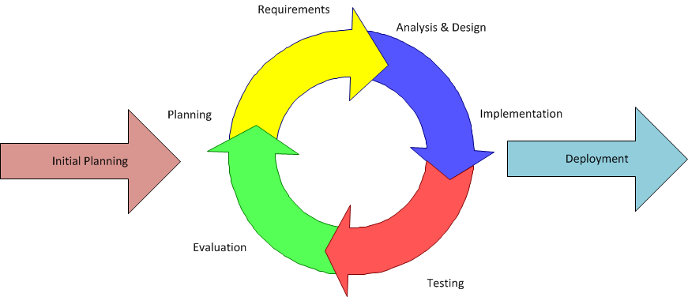

## 3.1 Iterative And Incremental Model

Iterative method is a mathematical procedure that generates a sequence of improving

approximate solutions for a class of problems. It is an act of repeating a process with

the aim of approaching a desired goal, target, or result.

### 3.1.1 Initial Planning Phase

The phase starts with brainstorming the ideas of current problems and system

requests. Then, continue the discussion with the supervisor to choose a project to be

implemented. Literature reviews with the current similar system are studied to find the problems of the systems.

### 3.1.2 Planning Phase

After deciding the title of the project and the approach to be used, the discussions

continue on defining the problem statements, deciding an objective, and defining the scope for the system. In order to get a better understanding, existing systems are reviewed and observed and constraints and limitations are gathered.

### 3.1.3 Requirements Phase

During this phase, existing systems are analyzed and all the requirements that are needed to develop the new system are identified. In this phase, the information regarding the House Rental System either in the form of journal, articles, or research papers are gathered and studied. All sources that were found were analyzed and observed the advantages and disadvantages. The information obtained about the House RentalSystem is crucial in producing the end product and achieving the system objectives.

### 3.1.4 Analysis and Design Phase

In this phase, the design of the system is created and the development of the prototype

is based on the functionalities that will be built such as adding a house, updating the house, and deleting the house. The data or requirement obtained during the requirement phase is transformed into a design. Examples of diagrams that will be built are Context Diagram (CD), Data Flow Diagram (DFD), and Entity Relationship Diagram (ERD). All These diagrams are built as a guideline for the flow of the system.

### 

### 3.1.5 Implementation Phase

The phase is also known as the code generation phase. The developer writes codes based on the previous phase. The system will be built using PHP,JavaScript, HTML, CSS, Bootstrap, JQuery etc. User interfaces are also included in the phases as they are important in delivering information and messages to the user.

## 3.2 Generic Model

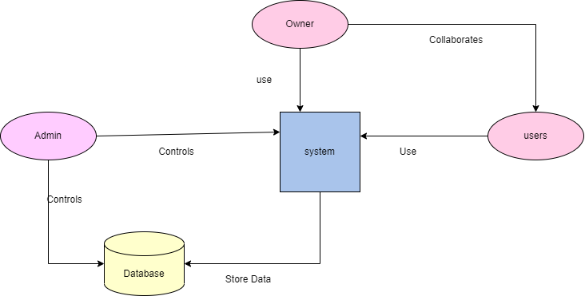

Fig 3.2: Basic diagram of the system

## 3.3 Project Management

### 3.3.1 Team Member:

All the team members are supportive, cooperative, and Innovative. All members of the team motivate and inspire each other to complete the task in a given time. As we had already done some projects in the past together, it would be more feasible to work together.

### 3.3.2 Feasibility Analysis

The feasibility study was carried out under the following three areas:

**Technical Feasibility**: The software requirements for the project will be

PHP,JavaScript, MySQL,HTML, CSS

**Economic Feasibility**: The cost of this project will be affordable enough and Hence it is quite feasible economically.

**Schedule Feasibility**-The schedule time for the completion of the project is 12 weeks and it should be feasible.

### **3.3.3 Work Schedule**

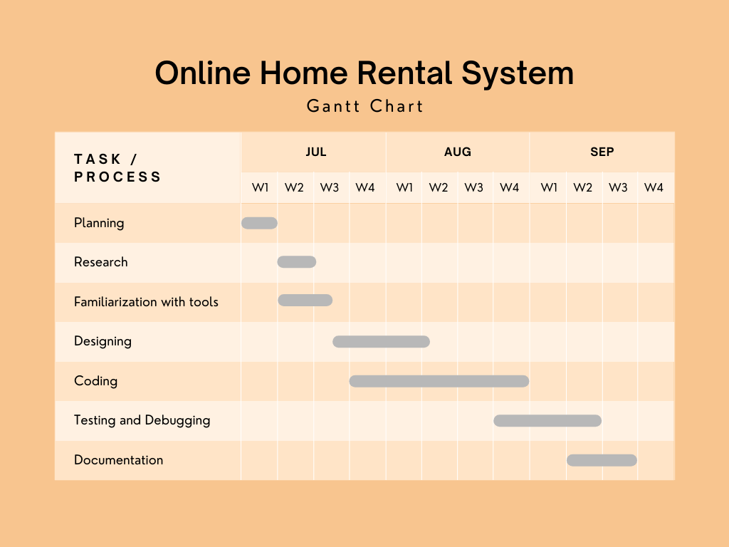

Fig 3.3.3 : Gantt Chart

## 3.4 Requirement Elicitation

**Functional Requirements:**

* By Prototyping
* User interface Analysis
* Documentation Analysis
* Registration process

**Non Functional Requirement**s **:**

* Security
* Performance
* Maintainability

## 3.5 System Design and Modeling

### 3.5.1 ER Diagram

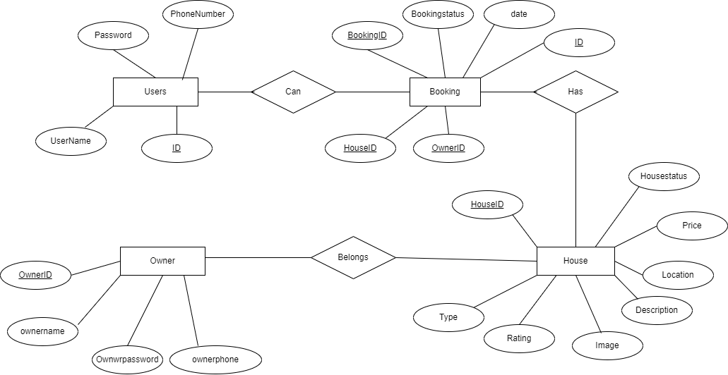

Fig 3.5.1: ER Diagram

### 3.5.2 Use Case Diagram

**Fig 3.5.2: UseCase Diagram**

**3.5.3 Context Diagram**

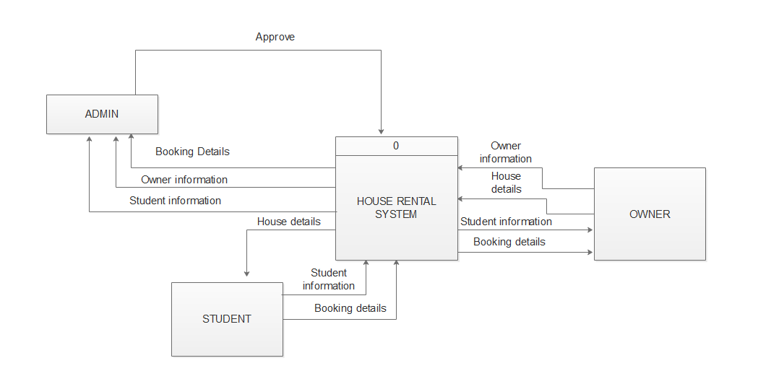

## Fig 3.5.3: Context Diagram

## 3.6 Coding tools and platform

* Core PHP, HTML, CSS
* Required hardware, OS and so on.
* MySQL
* Visual Studio Code .
* Xampp
* Code snippet

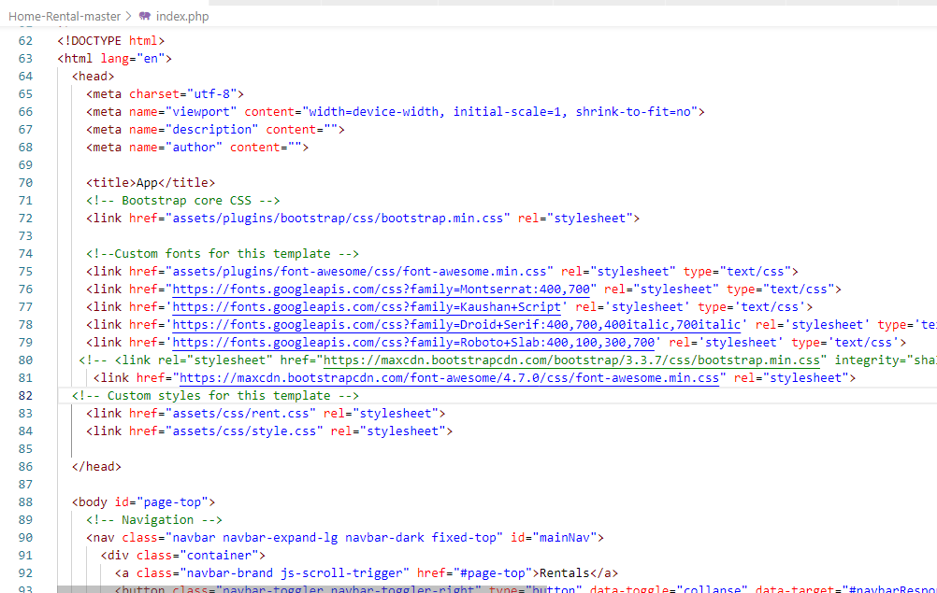

**Database Connection**

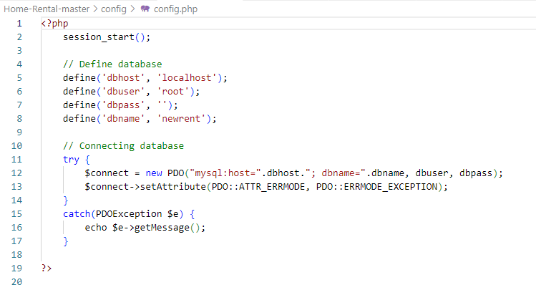

## 3.7 Testing

### Test Objectives

The main objectives of testing Online Home Rental were:

* To check whether the Web Application is built per the set objectives
* To ensure errors get fixed before deployment.
* To gain confidence in the level of quality of the system.

### Test Results

| **SN.** | **Test Cases** | **Expected** | **Observed** | **Results** |
| --- | --- | --- | --- | --- |
| **1.** | Authentication for the user and Home/Apartment/Room Owner | Customer and owner with the correct email and password can login. | Only specific emails with its respective correct password were logged in. | **OK** |
| **2.** | Register the properties. | Owner authenticated can only view details and book the time for specific time. | Only authenticated Owner was able to register their property. | **OK** |
| **3.** | Search the properties for non register user using different keywords | Anyone around the globe can access the webapp and search for the property in desired location. | Everyone were able to search property within certain location using different keywords | **OK** |

# **CHAPTER 4**

# LIMITATION AND FUTURE WORKS

### Limitations

As we know that there is something incomplete in the completion of certain work. There may be some technical error present. Some limitations are:

* At present, the system does not take care of the money payment methods.
* The system needs more elaborative technology for its inception and evolution.
* This application doesn't run without the internet.
* For now, we are unable to book the room/home directly through the book option.

### Futute Works

Some of the improvements that can be implemented in the future are as follows:

* Payment gateway integration.
* Google Map integration
* Better user Interface
* More information about Rentals and better searching of location.
* Improved security and system.
* Real time chat system for interaction between Owner and User.
* Implementation of room sharing features.

# **CHAPTER 5**

# CONCLUSION

The expected results of the project are that the students/Users can easily find a suitable house rental using this system. This system can help the student as a user to make a choice of the house rental .

# REFERENCES

1. Voumik, D., Deb, P., Sutradhar, S., & Khan, M. M. (2021, July 8). *Development of online based Smart House renting web application*. Journal of Software Engineering and Applications. Retrieved June 14, 2022, from https://www.scirp.org/journal/paperinformation.aspx?paperid=110723
2. Trasad, A. (2019, June 17). *Flowchart in software engineering/testing*. TechBytes. Retrieved June 14, 2022, from https://mundrisoft.com/tech-bytes/flowchart-in-software-engineering-testing/
3. Gommans, H. P., Njiru, G. M., & Owange, A. N. (1970, January 1). *[PDF] Rental House Management System: Semantic scholar*. [PDF] Rental House Management System | Semantic Scholar. Retrieved June 14, 2022, from https://www.semanticscholar.org/paper/Rental-House-Management-System-Gommans-Njiru/fe4a87307d05aa186e0ab0fd7b03b58948f81b56

# 